Meriweather Mowing
Meriweather Management System


Build Version: 1.0.0.205
Revision | Date | Who | Description
0.1 | 11/20/2009 | Andy Tan | Initial draft.
0.2 | 11/23/2009 | Andy Tan | Updates to match build.
0.3 | 11/28/2009 | Andy Tan | Updates
0.4 | 12/18/2009 | Andy Tan | Updates
Table of Contents

Meriweather Mowing 0
Introduction 1
About 1
Scope 1
Document Outline 2
Software Features Set 2
1. Software Installation 3
Software Updates 3
Password to the Login View 3
Installation Prerequisite 3
2. Main Window 4
3. Toolbar 5
4. Menu System 5
5. Login View 6
6. Data Grid Functionality 7
List Control 7
Pop-up Menu 7
Export to Excel 7
Search 7
7. Customer View 8
8. Employee view 10
9. Vendor View 11
10. Services View 12
11. Schedule View 12
12. Reports View 12
13. Materials View 12
14. Preferences 12
15. QuickBooks Integration 12
Invoice Synchronization 12
16. Miscellaneous 13
Printing 13
Preferences 13
Application Lock 13
Data Backup 13
17. Architecture Design 14
18. Current Defects 15

Introduction
Management System program is the designed specific for Meriweather Mowing Company. The purpose of this document is to describe the general functionality that is necessary to meet business objectives of the Meriweather management system software. This document will describe the functional features of the Meriweather management system version 1.0 software product.

About

This software program objective is to improve the Meriweather Mowing internal processes and provide the ability to expand on the technology for Meriweather Mowing service.

Scope
The scope of this document is the Meriweather Management System (MMS) version 1.0. The MMS system provides a user interface to facilite the daily processes associated in the Meriweather processes.

Document Outline
This document will describe the functionality of the Meriweather Management System software in a logic approach of development and will be a living document to explain how the software works. It is intended to provide guidance and an eventual manual for the software. The document will be written in sections that are consistent with the chronological order of development of each feature set. As a feature set is developed, the software will be delivered along with the updated version of this document.

Note: Document version on the cover will associate with the build version of the software.

Software Features Set
This document specifies functionality specific to the Meriweather Management System. Those features specified in this document that are not a part of the current feature set but maybe implemented if time permits are specifically noted in italicized for format.
Each of the major functionality of the software is depicted and accessed by the Toolbar (see Login View). Each of these major functionalities is hereafter referred to as “Views”.

The following are terms used in this document:

- Main Window - The main window encapsulates the entire application. It is the framework which includes all the menus, toolbar and the “Views”.

- Views – This describes the major functionality within the Main Window that can be activated via the toolbar.

- Dialog – These are windows that come up independently from the Main Window and are call “modal” whereby it captures the input with in it and the user cannot interact with the main window until it is closed.

Software Installation
Software can be downloaded and installed form the following:
http://thetans.homeserver.com/mms/publish.htm
Email Bugs, Questions, and Problems to: atan@sercio.com

Software Updates
The Check Update feature will let you check the Sercio webs site for the latest version. If there is a newer version, you will be able to download and install it from this screen. You must be connected to the internet to use this feature.
Click the Check Update button at the lower left had corner of the main window. If a new version is found, a message will be displayed. Click this button to download the update to your computer. Once the download is complete, the software will be updated. MMS will close after the installation and must be restarted from the Start Menu.

Password to the Login View
The user password and login is currently hard coded and cannot be changes. This will be configurable at the final version of the MMS System. Please use the following login and password:

Login: admin
Password: password

<NOTE: login and password has been set to “Blank” at this time, just press the “Login” button to enter the system.>

Installation Prerequisite
(downloadable free from MS website)
- SQL 2008 Express
- Crystal Reports 2008 (MS.Reports) runtime

Main Window

The main window is the main framework in which the application lives and comprises the following standard functionality.

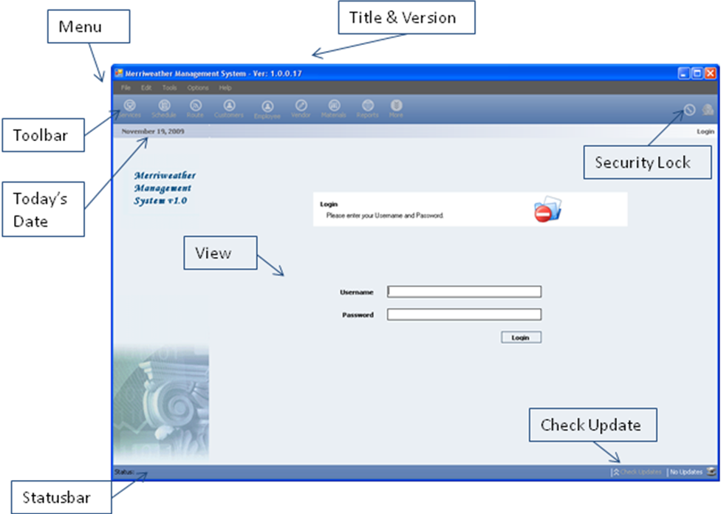
Feature | Description
Title & Version | Describes the title of the software, but importantly the version number. This is the build number and is incrementally increased with new updates. This is also consistent with this document.
Menu | The drop down menu system
Toolbar | This is the toolbar that has the major features and activates the “Views” of the system.
Today’s Date | This specifies the current date and will stamp any transaction with this date.
Security Lock | This is the application lock button.
View | This is a part of the main window that switches to different “views” of functionality.
StatusBar | The status bar will display descriptions and information during operation.
Check Update | The button will check if a new version of the software is available for download and updates the application accordingly.

Toolbar

The Toolbar provides navigation to the various functional Views to be displayed on the main screen. NOTE: Only those highlighted are enabled at this time.
Feature | Description
Services | Navigates to the Services View screen where the type of services can be selected for particular customers. Jobs are then created to be displayed on the Schedule View.
Schedule | Navigates to the Schedule View where jobs can be viewed and printed. Once a job is done, it needs to be checked off and noted for the system to record.
Route | Navigate to the Route View where routes can be created.
Customer | Navigates to the Customer View where customer and property information can be entered, edited or deleted.
Employee | Navigates to the Employee View where employee and contractor information can be entered, edited or deleted.
Vendor | Navigates to the Vendor View where vendor contact information can be entered, edited or deleted.
Materials | TBD - place holder
Reports | Navigates to the Report View where various reports can be generated for viewing and printing.
More | TBD - place holder
Lock | Locks the application and puts it back to the Login View.
Quickbooks | Launches the Quickbook application (shortcut)

Menu System
The following table describes commands available through the main menu. The “Menu / Item” column lists the main menu and sub-menu command names, the “Shortcut” column lists any shortcuts to this command, and the “Description” column briefly describes the command.

NOTE: The Menu items are currently yet TBD and non-functional.

Menu / Item | Shortcut | Description
Files
Print
Print Preview
Exit |  | Closes the main window and exits the program.

Edit

Options
Preferences |  | Launches the configuration dialog, not functional yet.

Help
About |  | Launches the About dialog, contains software version

Login View
This View provides the initial screen and the lock screen state for security of the system.
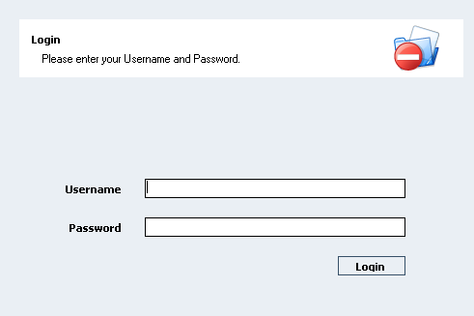

The user password and login is currently hard coded and cannot be changes. This will be configurable at the final version of the MMS System. Please use the following login and password:

Login: admin
Password: password

<NOTE: login and password has been set to “Blank” at this time, just press the “Login” button to enter the system.>

Data Grid Functionality

List Control
Each Data Grid in the system has an associated list control that allows the user to step through the data manually via a mouse. It contains the associated data number and the number of listing that the Data Grid contains. Stepping through the data can also be done via the arrow keys.

Pop-up Menu
The Pop-up Menu on the Data Grid allows for customizing columns. The columns on the grid can be selected or deselected for viewing.
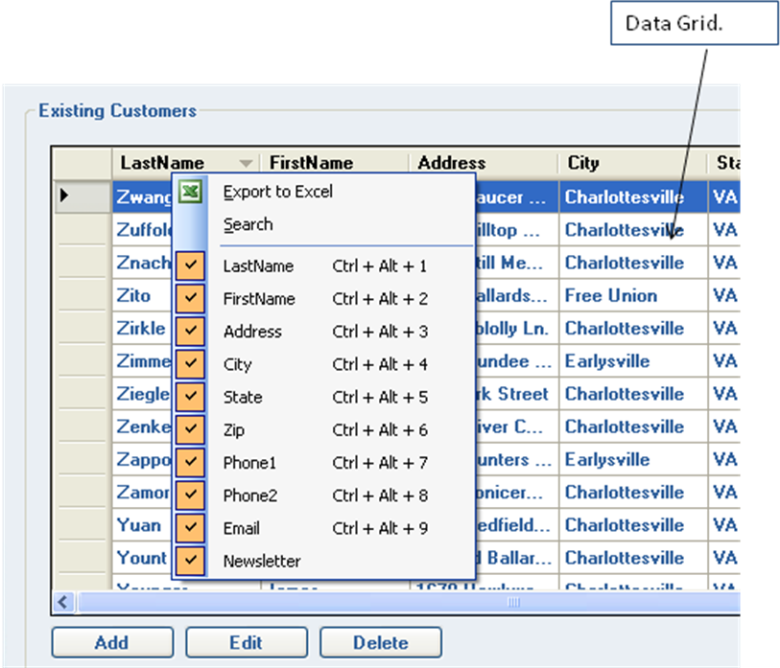

Export to Excel
An “Export to Excel” function is available for all Data Grid in the software. This functionality will export all the data in the Data Grid and launch an Excel spreadsheet with the data.

Search
Selecting the Search on the Pop-Menu will bring up a search control at the bottom of the Data Grid. Please note that this search functionality works on a “Column” basis. The user must first select the column and then select the Search menu item. The search functionality will search any context on the associated column.
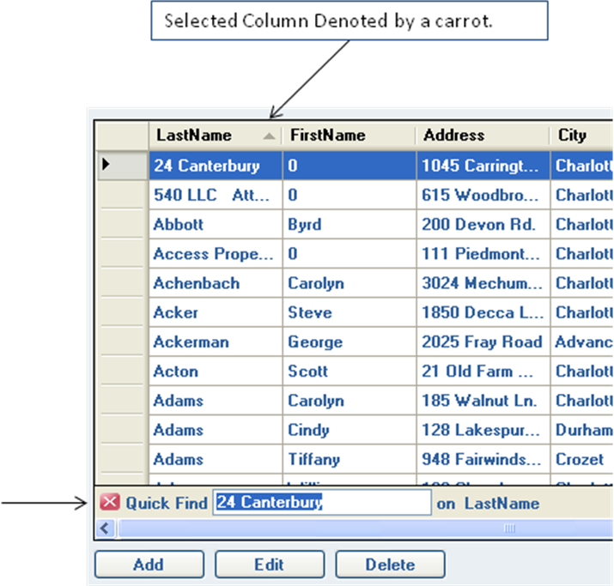

Customer View
The Customer Data Grid shows information for all customers. A customer can have one or more properties as defined by the Properties Data Grid below it. When a customer is selected, the associated Properties can be viewed.
The Customer Data Grid work much like a spreadsheet, where by any cell can be edited and saved in one action. The Grid can be put in Edit mode and changes can be done anywhere on the grid. Once saved, the entire Data Grid will be saved.
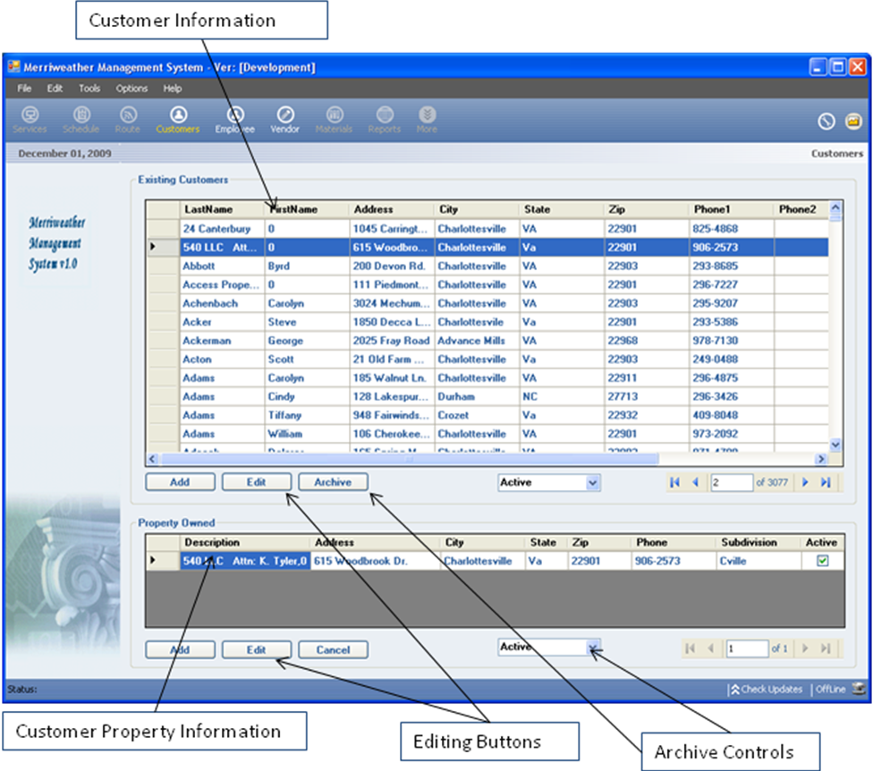

The “Add” button will create a new row in which the user can enter new customer information. Once saved, properties can then be added for that particular customer. The Add button will become the save button once pressed.

Customer information can be edited via pressing the “Edit” Button. Once pressed, the “Edit” Button will put the Data Grid into edit mode. The “Edit” button will turn into the “Save” button for the user to save any changes associated with the entire grid.

A whole row can be deleted by selecting a row and pressing the “Archive” button. This entry is not deleted and will be removed from the active view. The archive “droplist” will allow the view to toggle between Archive and Active view. In order to “Un-archive” an entry, the checkbox marked “Active” has to be selected, which can be done via the Edit functionality in the Archive list.

Employee view
The Employee View is the repository for employee and contractor information
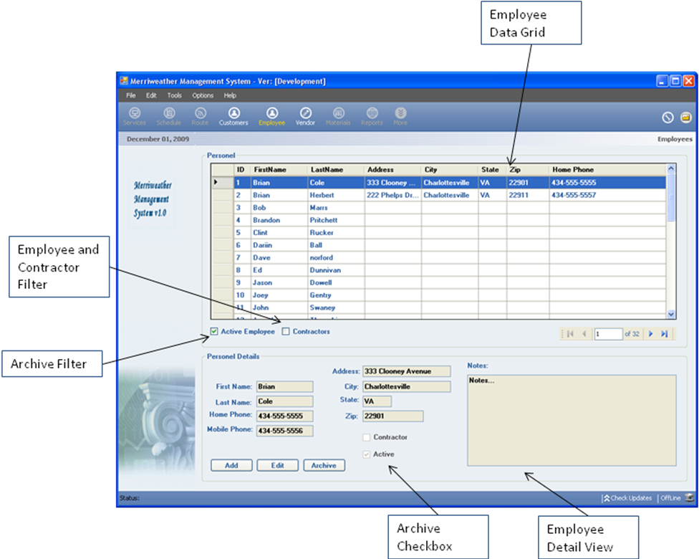
Selecting a particular employee in the Employee View will enable information in the Detail View section for that particular employee.
Adding and modifying any information is done via the “Detail View”. Once information edited via the Edit button, the Edit button will transform to become the Save button. Any edited information must be saved.
An employee can be “Active” or not Active, by selecting the “Active” checkbox (Archiving). An employee can also be designated as a contractor by selecting the “Contractor” checkbox. The “Employee and Contractor Filter” can be selected to view Active Employee or just Contractors by selecting the appropriate filter checkbox.

Vendor View
The Vender View is the repository for vendor information The View consist of a Data Grid and a Details section.

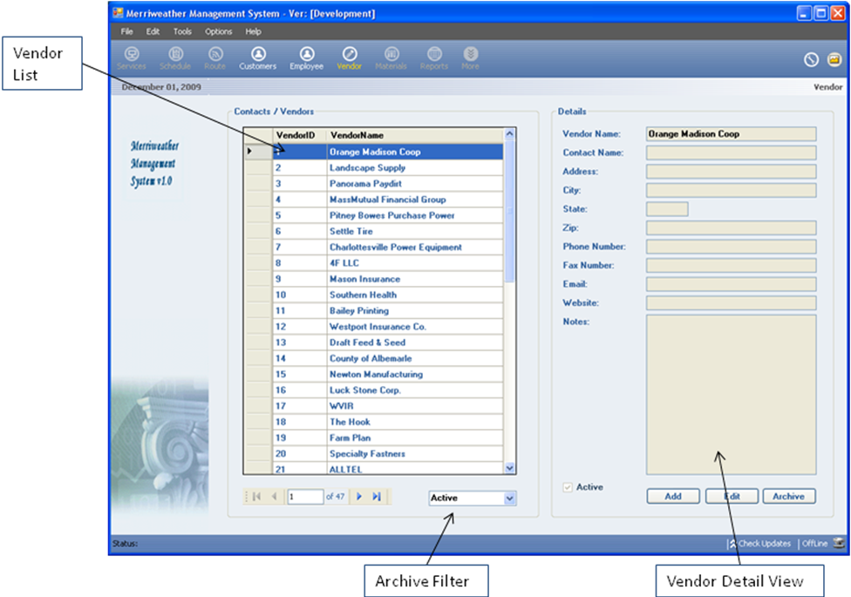

Selecting a particular vendor in the Vendor View will enable information in the Detail View section for that particular employee.
Adding and modifying any information is done via the “Detail View”. Once information edited via the Edit button, the Edit button will transform to become the Save button. Any edited information must be saved.
A vendor can be “Active” or not Active, by selecting the “Active” checkbox (Archiving). The “Archive Filter” can be selected to view Active and Non-Active vendors by selecting the appropriate filter droplist.

Services View

This view is currently being developed…. Updates coming soon!
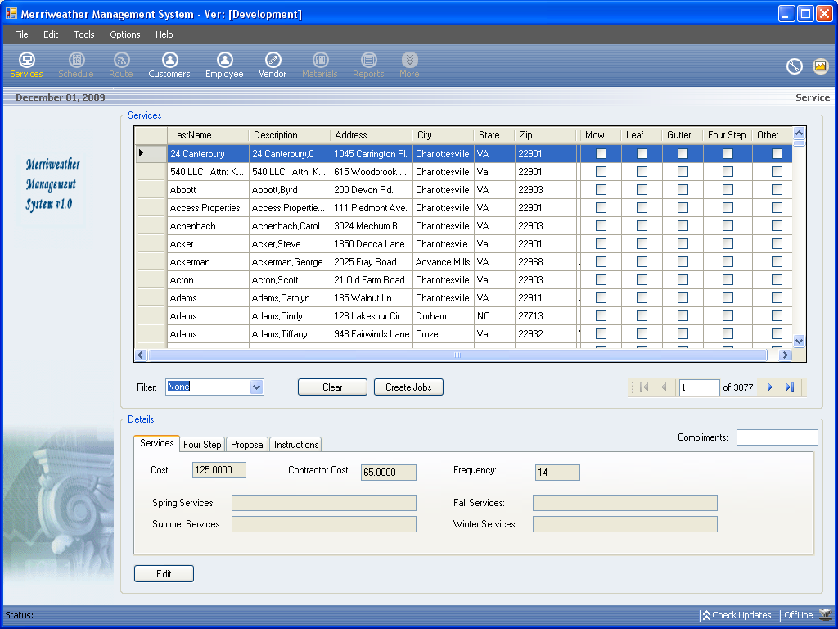

Schedule View

Reports View

Materials View
Materials View is TBD

Preferences

QuickBooks Integration

Invoice Synchronization

Miscellaneous

Printing

Preferences

Application Lock

Data Backup

Architecture Design
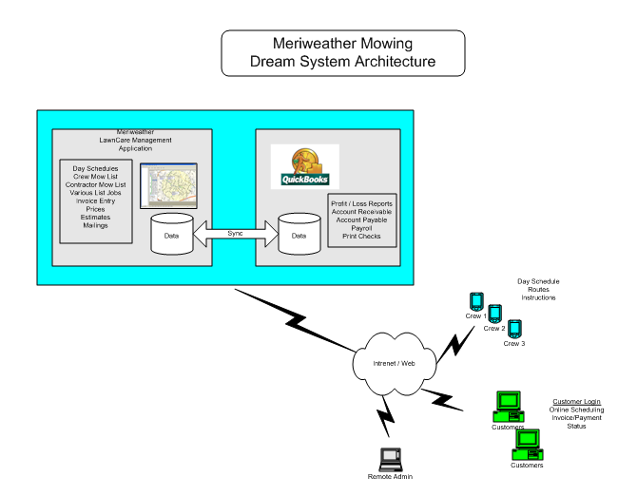

Current Defects

View | Description | Status | Notes
CustomerView | Cannot Delete Entry w/ associated Property | Completed | Delete becomes archived
CustomerView | Customer ID must be hidden | Completed
CustomerView | When Editing Customer, Disable Property Controls, edit, etc. | Completed
CustomerView | When Edititing, disable Customer Grid Controls | Completed
CustomerView | When Editing, don’t let user switch View | Completed
CustomerView | Lock Selection when Adding Cust or Property | Completed
CustomerView | validate cell entry | Pending | Need to check input, integers, etc.
EmployeeView | validate cell entry | Pending | Need to check input, integers, etc.
CustomerView | When in Archive View, disable "Archive" button | Completed
Vendor View | validate cell entry | Pending | Need to check input, integers, etc.
Please leave this page blank.

